List of Tools and Components Used

# Revision

Version 4

11/15/21 10:46 AM

# SME

Charles Wilson

# Abstract

This document describes the process to track the software used in the creation of an autonomous vehicle.

# Group / Owner

Development / Software Developer

# Motivation

This document is motivated by the need to have formal processes in place tracking the tools and components used in creation of safety-critical, cyber-physical systems for certification of compliance to standards such as ISO 21434 and 26262.

# License

This work was created by **Motional** and is licensed under the **Creative Commons Attribution-Share Alike (CC4-SA)** License.

[**https://creativecommons.org/licenses/by/4.0/legalcode**](https://creativecommons.org/licenses/by/4.0/legalcode)

# Overview

In order to ensure the security of the software to be produced, it is necessary to validate and enumerate the software used in its creation. The process of selection and validation of the tools used is documented in the **List of Approved Tools and Components** secondary document. During the actual creation of the software, it is necessary to verify that the tools and components being used are the ones approved during that process.

Below is the overview of the process use to verify that the appropriate tools / components are being used for product creation.

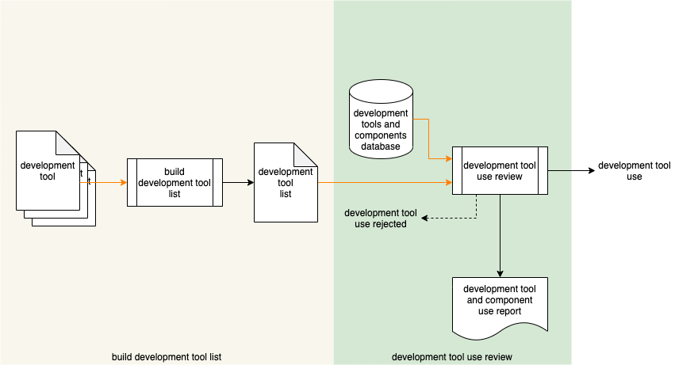

**Note:** This process is intended to be inserted into an existing build process.

**Note:** In order to avoid constantly repeating the phrase “tool / component,” **tool** is used to refer to either a **tool** or a **component**.

# Process

## Build Development Tool List

|  |  |
| --- | --- |
| Inputs | development tool(s) |
| Outputs | development tool list |
| Participants | none |

A list of development tools to be used is constructed a **development tools list**. This list should be constructed from the individual tools’ metadata information.

**Note:** The preferred form of tool metadata is SPDX encoded JSON for software components (raw source / libraries) and SWID encoded JSON for executables.

## Development Tool Use Review

|  |  |
| --- | --- |
| Inputs | development tool list  development tools database |
| Outputs | none |
| Participants | none |

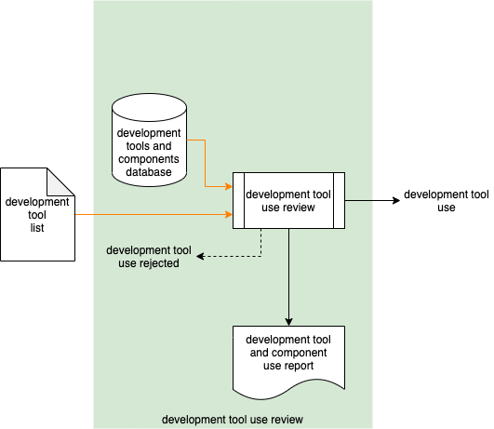

The **development tools list** is reviewed against the **development tools and components database** to verify that all entries in the list have been approved for use in the project. A **development tool and component use report** documenting the outcome of the review is generated. If any tools are not in the set approved for the project, a **development tool use rejected** notification is generated.

# References

1. **List of Approved Tools and Components** (AVCDL secondary document)
2. **Software Package Data Exchange® (SPDX®)**  
   <https://spdx.dev/wp-content/uploads/sites/41/2017/12/spdxversion2.1.pdf>
3. ISO 19770-2:2015 **Information technology - IT asset management - Part 2: Software identification tag**<https://www.iso.org/standard/65666.html>
4. NIST IR 8060 **Guidelines for the Creation of Interoperable Software Identification (SWID) Tags**  
   <https://nvlpubs.nist.gov/nistpubs/ir/2016/NIST.IR.8060.pdf>